**RESUME** 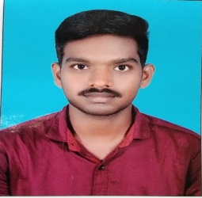

**UTNURI VAMSHIKRISHNA**

**E-mail:**dhonivamshi7@gmail.com

**Mobile number:**9492384592

**Career objective**

To be a part of organization where one can work effectively for personal and professional organization growth in a challenging environment.

**Educational qualification**

|  |  |  |  |  |
| --- | --- | --- | --- | --- |
| **course** | **institution** | **University or Board** | **Year of passing** | **percentage** |
| BSC(BTZC) | Masterji Degree and PG college | Kakatiya university | 2016-2019 | 78% |
| BIPC | Geethanjali junior college | Board of intermediate | 2014-2016 | 78% |
| SSC | Adarsha High school | Board of secondary education | 2014 | 83% |

**Strengths**

* Workaholic.
* Good communication skills.
* Good presentation skills.
* Easy mingle with anyone.
* Creativity.

**Technical skills**

* PGDCA
* MS EXCEL
* MS word
* Ui DEVELOPER

(Html,Css,Bootstrap,Javascript,Jquary,Angular8,Ajax)

* PHOTOSHOP DESGINING
* PHP

**Personal details**

Name : Utnuri vamshikrishna

Father’s name **:**  Srinivas

Mother’ s name : shilaja

DOB : 15-01-1998

Gender : Male

Nationality : Indian

Religion : Hindu

Marital status : Single

Hobbies : Reading, writing skits,moti vational

Spekar and singhing.

Languages known : English,Telugu,Hindi.

Permanent address : H-NO:6-61,Damarkunta,lakshmipur **Declaration**

.